**CRUD Operations**

**Index API**

* In Elastic search, adding a document to a type within an index is called Indexing.
* Indexing involves adding a document to the index by parsing all the fields with in a document and building the inverted index. This is called as *indexing operation*
* We can create index in two ways
  + Indexing a document by providing an ID 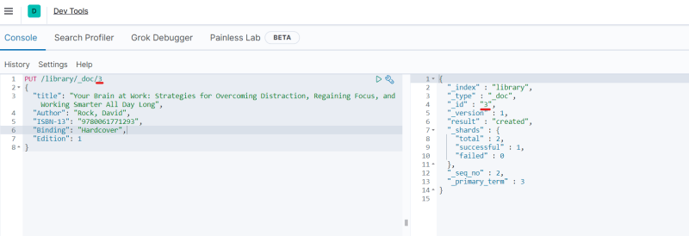
  + Indexing a document without providing an ID 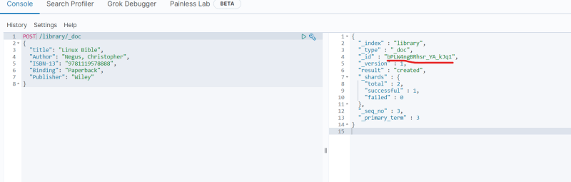
* Lets use GET API <https://www.elastic.co/guide/en/elasticsearch/reference/current/indices-get-index.html> for the official docs 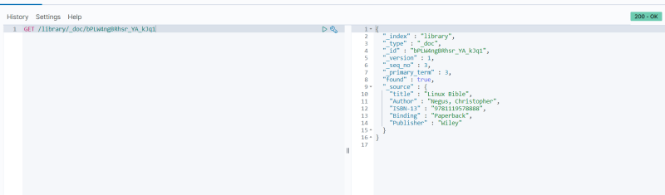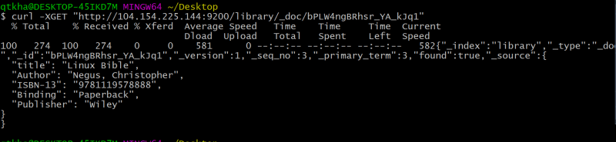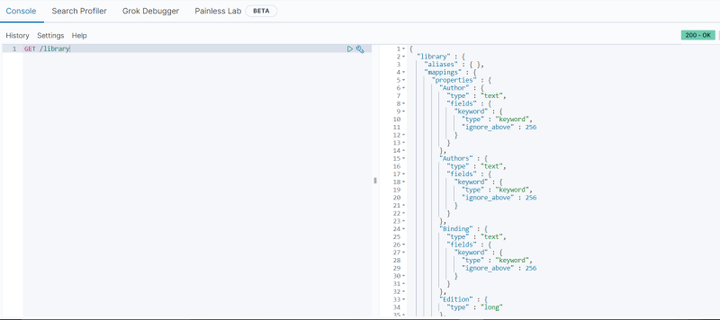
* Update document in index 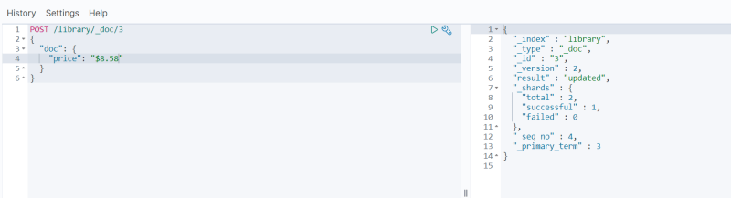
* Delete document in index 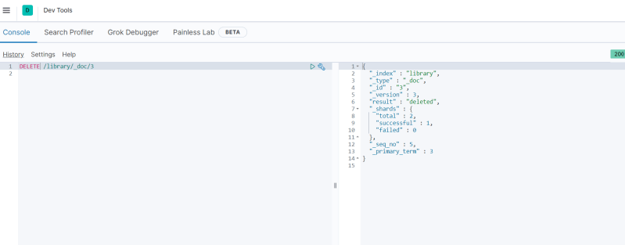
* Creating a index with Mappings 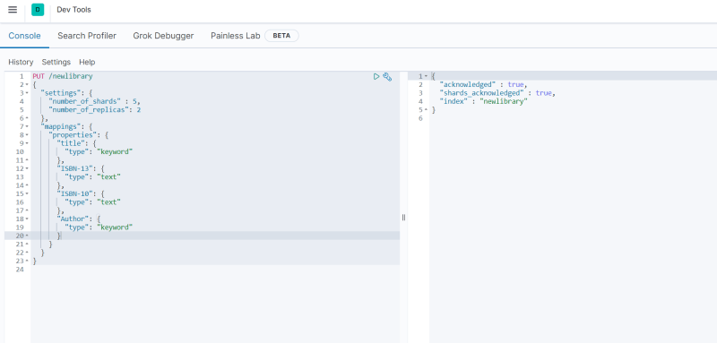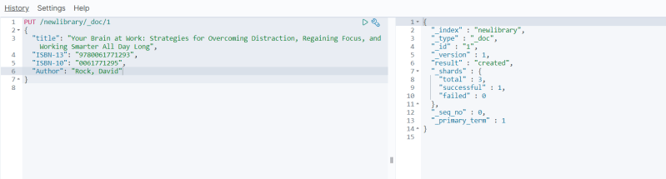

**Dealing with multiple indexes**

* <https://www.elastic.co/guide/en/elasticsearch/reference/current/search-search.html> for search apis
* Searching document in one or more indexes index 